What is Facebook Business Manager?
Business Manager is a tool designed for managing your Facebook Pages and ad accounts.
By using Business Manager, you can:
- Manage access to your Facebook Pages and ad accounts – see what individuals have access to your Pages and ad accounts and remove or change their permissions.
- Work with agencies – you can also share your Business Manager account with agencies so that they can help you manage your ad campaigns.
You can have multiple ad accounts and users all combined under your Business Manager account.
Here’s a quick overview of the two roles available in Facebook Business Manager: Admin and Employee:
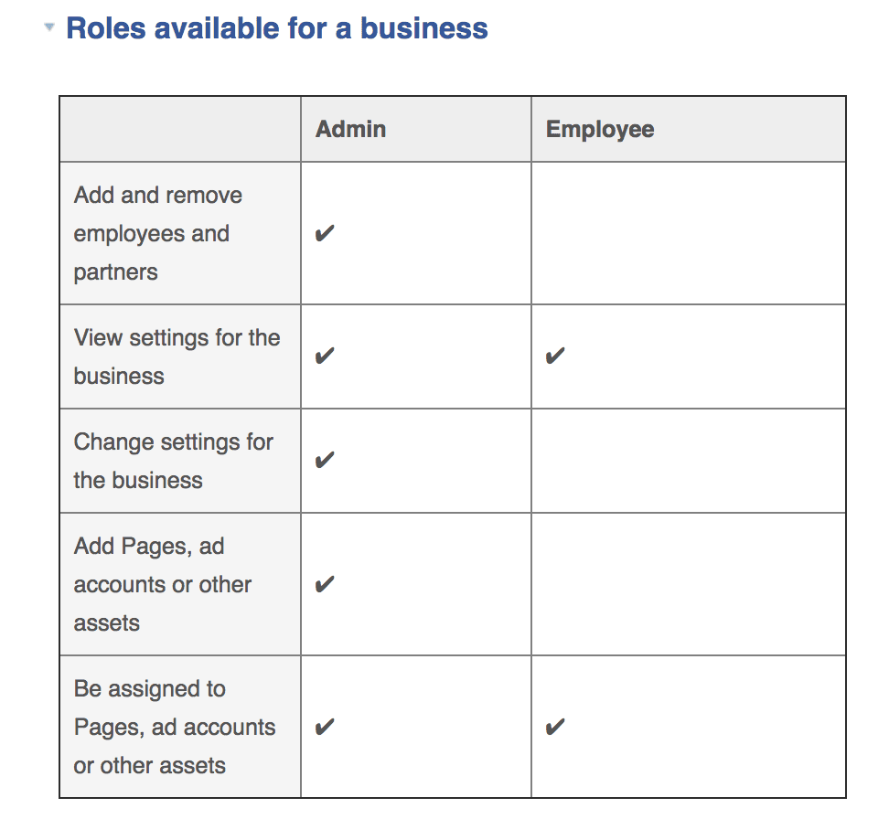
There’s a different set of roles for Facebook ad accounts that you can also manage and edit in the Business Manager.
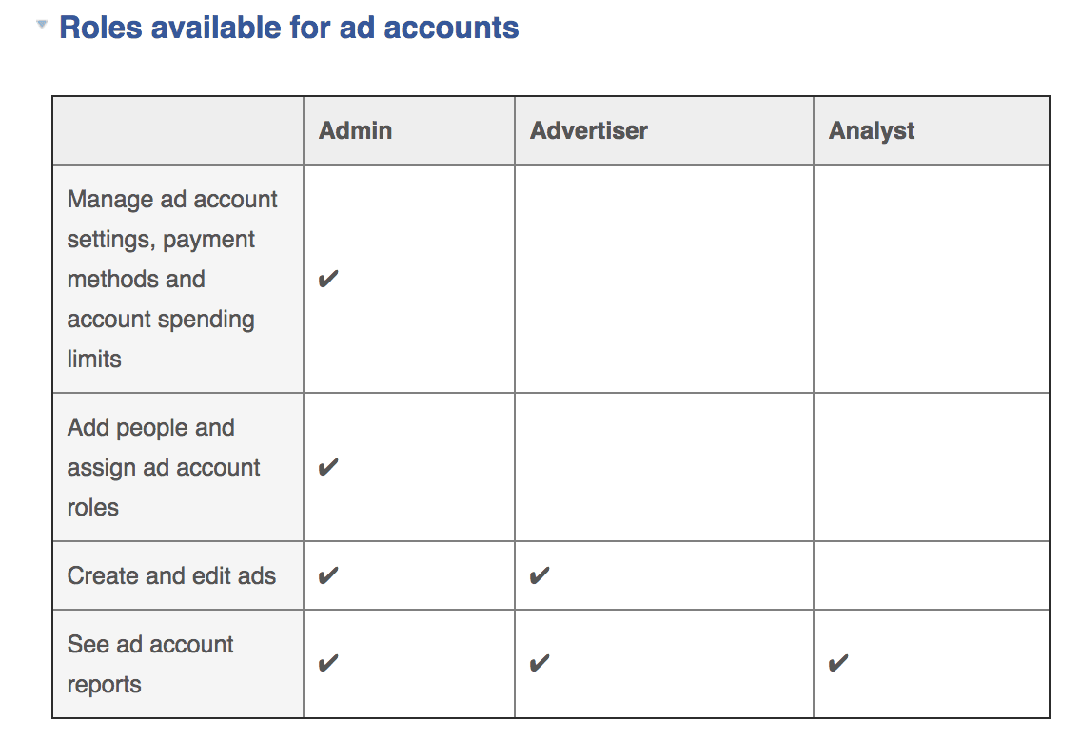
In order to create a campaign, your business manager must manage at least one Facebook page.
To add a Facebook page to your business manager:
- Go to Business Manager Settings
- On the left, click on Accounts -> Pages
- In the Pages column, click on the “Add Page” CTA
- Select one of the 3 options: “Claim a Page”, “Request Access to a Page” or “Create a New Page”
- If you choose to request access or claim a Page, enter the Facebook page name or URL

To add an advertising account to your Business Manager:
- Go to Business Manager Settings
- On the left, click on Accounts -> Ad Accounts
- In the Ad Account column, click on the blue “Add Account” CTA
- Choose one of the 3 options: “Claim Ad Account”, “Request Access to an Ad Account” or “Create a New Ad Account”
- If you choose to request access or claim an ad account, enter the ad account ID. (Learn where to find the account ID)

Before you can start advertising, you’ll need to give Facebook additional account information and enter your credit card data as a payment method for your ads.

Setting Up Your Ad Account Info
You can’t publish your first campaign without setting up your payment method. This pays for the running of your ads. Once you set up your ad account, you won’t have to do this again until you need to change the payment method or create a new ad account.
Let’s navigate to our ad account settings and set this up!
Go to your Business Manager and from there, click on “Ad Accounts” located under “Accounts”. Fill in all the blanks by entering your company’s name, address, and other relevant information.
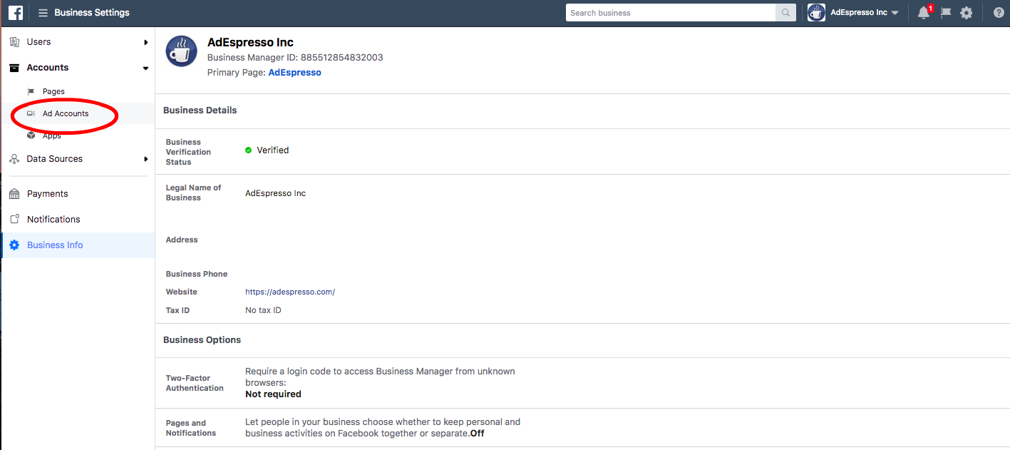

If you’re a business in the EU, you’ll also be prompted to insert your VAT number. Facebook will allow you to choose your billing currency and your timezone. Be extremely careful with this information as you won’t be able to change it once you’ve created your ad account account.
Once you enter your company information, you will need to enter your billing details.

Setting Up Your Billing & Payment Information
Now it’s time to add our payment method so we can move forward with creating a Facebook campaign. Click on your ad account settings -> Payment Settings. From here, we can insert our cc or payment method details.
You will land on the Billing page where you can:
- Add new payment methods
- Edit your current payment methods
- Set your account’s spending limit
- See your next bill
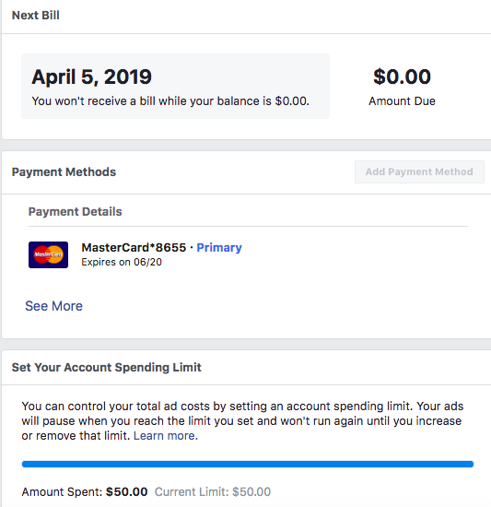
To add a new payment method to your ad account:
- Click on “Add Payment Method” button
- Choose the method you want to add
- Fill in your information
- Click on “Continue”
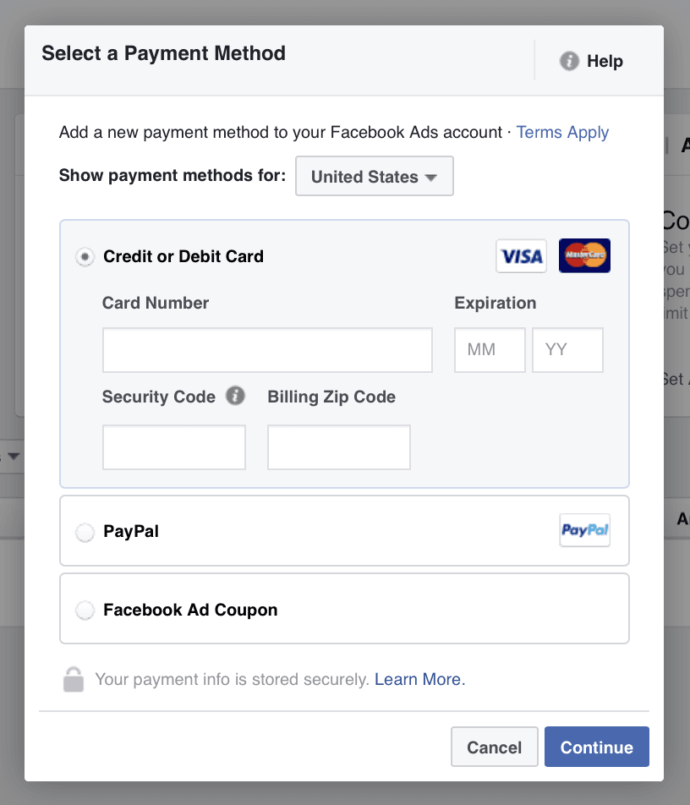
Facebook accepts multiple payment options, including credit cards and PayPal payments so you have a good amount of flexibility when it comes to how you are paying for your Facebook ads.
If you need additional help, here’s Facebook’s guide that explains how your ad billing and payments work.

Pro Tip: Add multiple payment options
As you start advertising more and more, we suggest that you add a secondary payment method. This prevents Facebook from stopping all of your campaigns should your primary card expire, reach the monthly limit, or be blocked for whatever reason.
When your primary card billing fails, all of your campaigns will be immediately paused until you pay the outstanding balance. This can be hugely disadvantageous if you are running campaigns for a very long time that are performing very well, as the pause will interrupt the learning that has been done on the campaign so far.
If you have a secondary payment method setup, Facebook will begin billing your secondary method and everything will keep working smoothly.
You can also edit your payment method from the payment settings screen.
Take note that you cannot delete your primary source, so you’ll need to make another option your primary source before removing your current primary payment method.

Editing Your Payment Options
If you want to make changes to your Facebook advertising payments, you can do it on the same page by clicking on “Edit Payment Methods.”
If you have entered multiple payment options, you can choose which one’s primary.
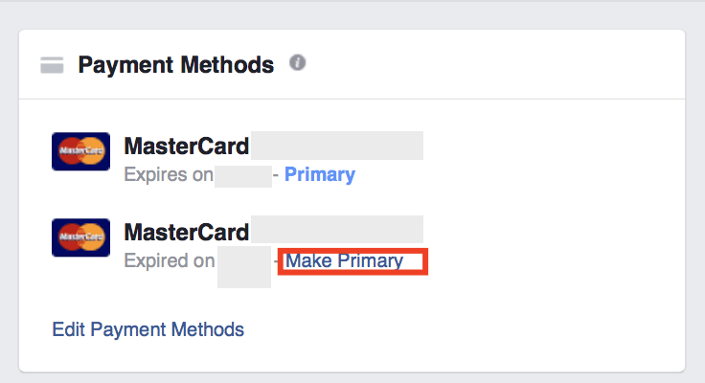
Note that you cannot delete your primary source, so you’ll need to make another option your primary source before removing your current primary payment method.

How and when are you billed?
You can expect a bill from Facebook on two occasions:
- At the end of every month
- When you reach your billing threshold (if you use direct debit to pay for Facebook ads)
The billing threshold means that your primary payment method will be charged every time you reach a certain billing threshold. The sum of the threshold varies based on your billing history.
This threshold will be pretty low when you first start advertising (usually $25), and you’ll be billed every time you spend $25 in Facebook Ads. As you keep spending and your payments are correctly processed, your threshold will be automatically increased to $50, $250, $500, and finally, $750.
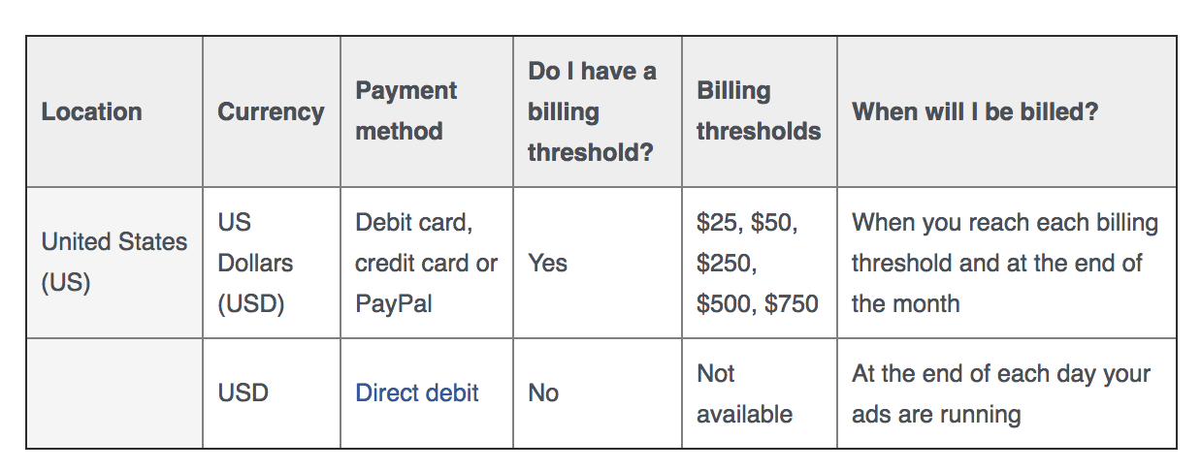
These thresholds don’t have any direct impact on your advertising campaigns; they just affect how often you’ll be charged. The big advantage of having a high threshold is that you’ll have to deal with fewer invoices. If you want to change your threshold or have problems with billing, you can contact Facebook support.

Setting up the account spending limit
You can control your total ad costs by setting an ad account spending limit. Your ads will pause when you reach the limit you set and won’t run again until you increase or remove that limit. Keep this in mind in the future should you ever find your ads are not running and you don’t recall why!
Ad account spending limits are especially useful when working with agencies, when you want to be sure your consultant or agency won’t be able to spend more than you’ve planned across all of your campaigns. Don’t set it too low or you’ll have to update it very often. Remember that each time the limit is reached, all of your accounts will be paused for at least 15 minutes.
As a final note, rest assured that the account spending limit doesn’t have any impact on your ad delivery pace.

Facebook Ad Account Limits
Whether you like it or not, your Facebook Advertising account will have some limits. They should not bother you most of the time, but it’s better to get to know them from the beginning.
Here are the limits of Facebook Ads Manager:
A user can manage up to 25 ad accounts.
An ad account can have a max of 25 users per account.
A regular ad account can have up to 5,000 ads that aren’t deleted.
A regular ad account can have up to 1,000 sets that aren’t deleted.
A regular ad account can have up to 1,000 campaigns that aren’t deleted.
An ad account can have up to 50 ads that aren’t deleted per ad set.
These limits only apply to non-deleted ads and campaigns. Once you reach any of these limits, all you’ll have to do is delete old campaigns and their ads.

Review Your Notification Settings
It comes without saying that you’ll want to be informed about important updates happening on your advertising account.
Facebook Notifications are a good way to stay in touch with your campaigns. However, they can also flood your inbox very quickly, so you may want to change the frequency of email notifications you receive from Facebook to fit your needs.

To edit your notification settings:
- Navigate back to your ad account settings
- Click on “Notifications”
- Add or Remove what events you wish to receive email notifications about
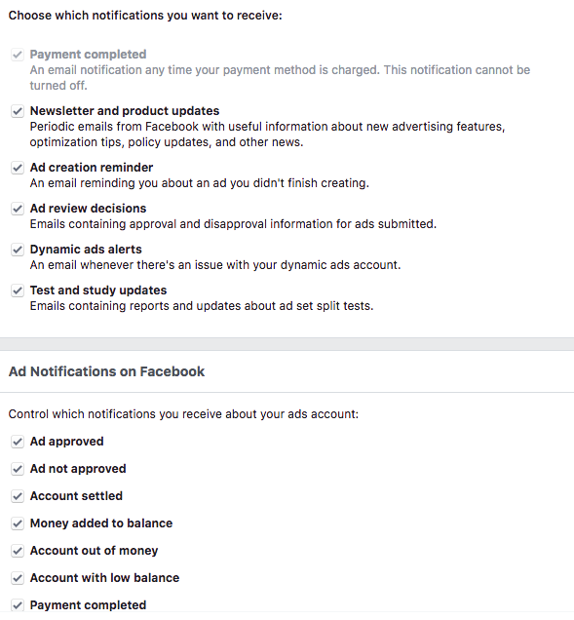
Set up your notifications so that you’ll get the most important notifications via email and others as Facebook notifications that will appear when you log in to your business manager.

Review Your Ad Account Roles
Once you have been creating ads for a while you may wish to collaborate with another person. This is where roles come into play. If you want to add new users and admins to your Facebook advertising account, navigate to the “Account Roles” menu tab.
In your ad account settings, click on “Ad Accounts” and scroll down to the bottom. Beneath your attribution settings, you’ll be able to set roles.
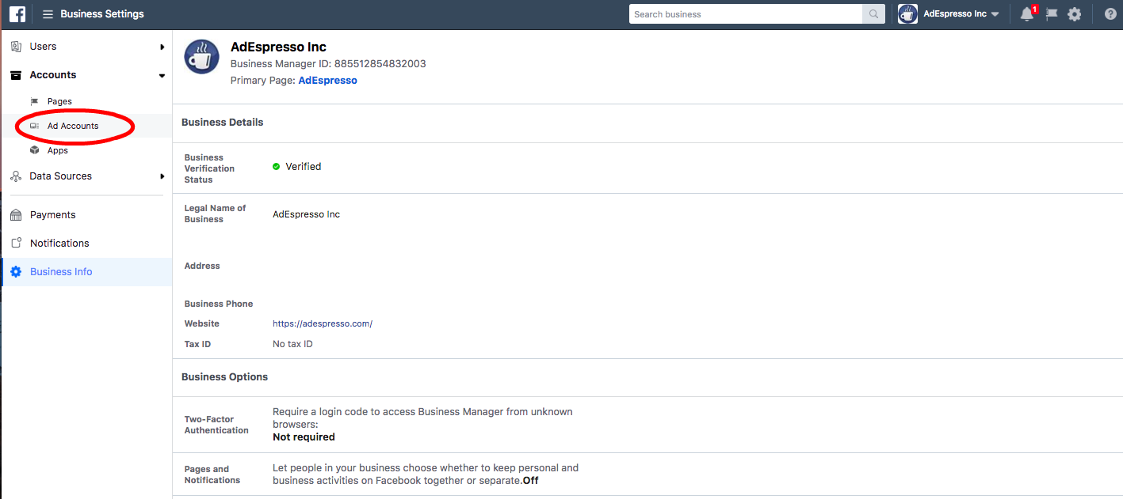
Once you click on “Add People”, you’ll be able to add new users and edit the existing users’ permissions
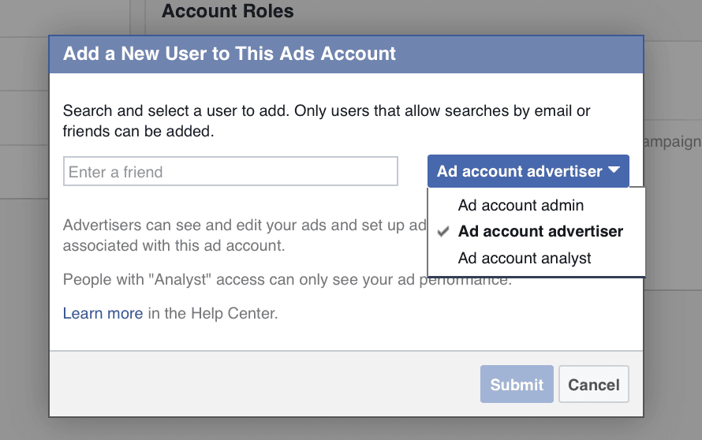
Once you’ve completed the account management and invited your team members, you’re all set.

Congratulations! You’re ready to go!
Your Facebook ad account is finally ready and waiting for you to set up those first campaigns!

